**WORKSHOP 6**

NAME: _______________________________________________________

I. Listen to the dialogues and complete the gaps with the missing words.

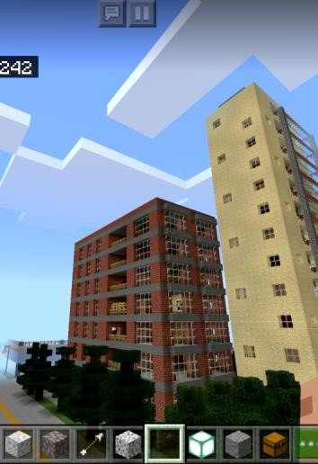

|  |  |
| --- | --- |
| **DIALOG 1** | **Tom:** Hey, Dad, how often do you ?  **Dad:** I go online at work.  **Tom:** Oh? Why is that?  **Dad:** I have to my customers every day. |
|  | |
| **DIALOG 2**  **attach a file** | **Tom:** Dad, I need your help with my .  **Dad:** Sure. How can I help you?  **Tom:** I don’t know how to .  **Dad:** It’s easy! Here, let me you. |
|  | |
| **DIALOG 3** | **Julia:** What’s your , Tom?  **Tom:** Well, , of course.  **Julia:** Really? ?  **Tom:** Because I can watch gaming videos about my favorite online games! Like *Roblox* and *Minecraft*! |



**WRITING PRACTICE**

II. Write a short paragraph to describe your internet habits. Remember to include information such as how often you go online, about how many hours each day you are online, and what your favorite internet sites are.

__________________________________________________________________________________________________________________________________________________________________________________________________________________________________________________________________________________________________________________________________________________________________________________________________________________________________________________________________________________________________________________________________________________________________________________________________________________________________________________________________________________________________________________________________________________________________________________________________________________________________________________________________________________________________________________________________________________________________